**C-DAC Mumbai Date 25/09/2024**

**Subject: Algorithm and Data Structure**

**Assignment 1**

**Solve the assignment with following thing to be added in each question.**

-Program

-Flow chart

-Explanation

-Output

-Time and Space complexity

1. Armstrong Number

Problem: Write a Java program to check if a given number is an Armstrong number.

**Program:**

import java.util.Scanner;

public class ArmstrongNumber {

public static void main(String[] args) {

Scanner scanner = new Scanner(System.in);

System.out.println("Enter a number: ");

int number = scanner.nextInt();

scanner.close();

if (isArmstrong(number)) {

System.out.println(number + " is an Armstrong number");

} else {

System.out.println(number + " is not an Armstrong number");

}

}

/**

* Checks if a number is an Armstrong number.

*

* @param number the number to check

* @return true if the number is an Armstrong number, false otherwise

*/

public static boolean isArmstrong(int number) {

int originalNumber = number;

int sum = 0;

int digitCount = String.valueOf(number).length();

while (number != 0) {

int digit = number % 10;

sum += (int) Math.pow(digit, digitCount);

number /= 10;

}

return sum == originalNumber;

}

}

**Flow chart:-** 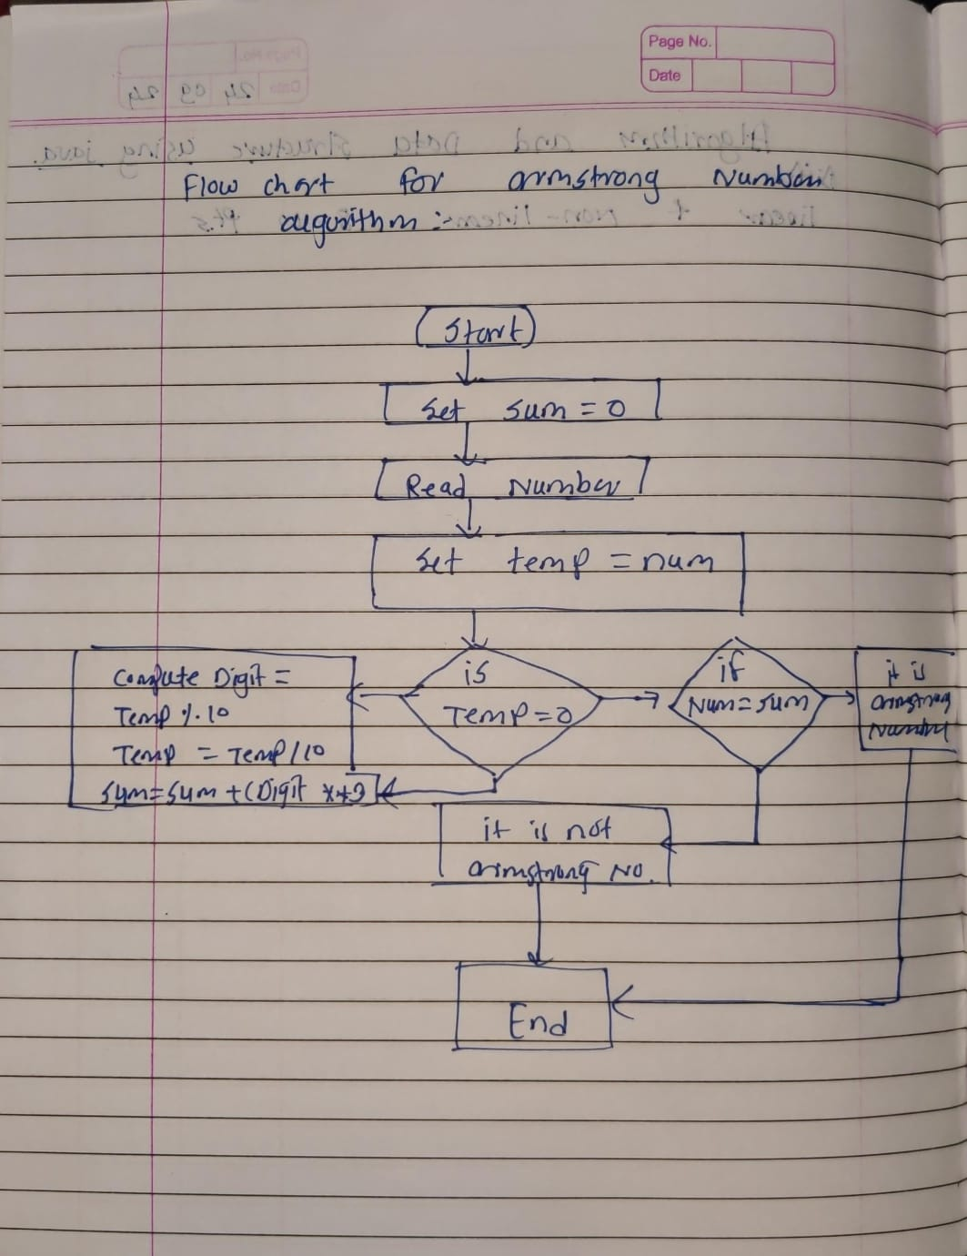

**Explanation:-**

Step-by-Step Explanation:

1. Counting Digits: The program first counts the number of digits in the given number using a while loop.
2. Calculating Sum: Then, it calculates the sum of the cubes of each digit using another while loop.
3. Comparing Sum and Number: Finally, it compares the calculated sum with the original number. If they are equal, the number is an Armstrong number.

Key Variables:

* temp: A temporary variable used to store the original number and later to calculate the sum.
* digits: The number of digits in the given number.
* last: The last digit of the number in each iteration.
* sum: The sum of the cubes of each digit.

Method isArmstrong(int n): This method takes an integer n as input and returns a boolean value indicating whether n is an Armstrong number or not.

main Method: The main method is the entry point of the program. It calls the isArmstrong method with a sample number (371) and prints the result.

**Output:-**

Input: 153

Output: true

Input: 123

Output: false

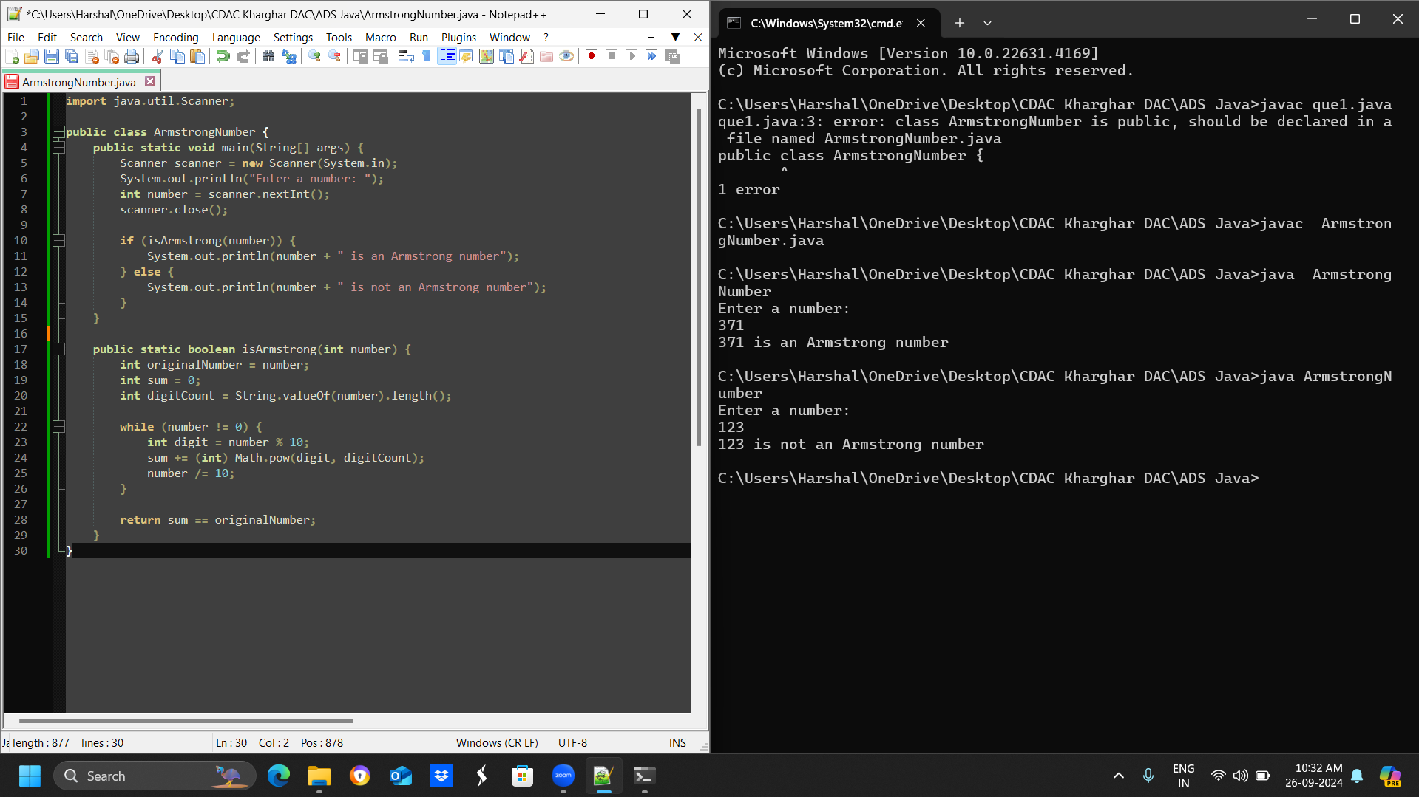

**Time and Space complexity:-**

The time complexity of this program is O(log n)

The space complexity of this program is O(1)

**2. Prime Number**

**Problem: Write a Java program to check if a given number is prime.**

Test Cases:

Input: 29

Output: true

Input: 15

Output: false

**Program:-**

import java.util.Scanner;

public class PrimeNumberChecker {

public static void main(String[] args) {

Scanner scanner = new Scanner(System.in);

System.out.print("Enter a number: ");

int num = scanner.nextInt();

if (isPrime(num)) {

System.out.println(num + " is a prime number.");

} else {

System.out.println(num + " is not a prime number.");

}

}

public static boolean isPrime(int num) {

if (num <= 1) {

return false;

}

for (int i = 2; i <= Math.sqrt(num); i++) {

if (num % i == 0) {

return false;

}

}

return true;

}

}

**Flow chart:-**

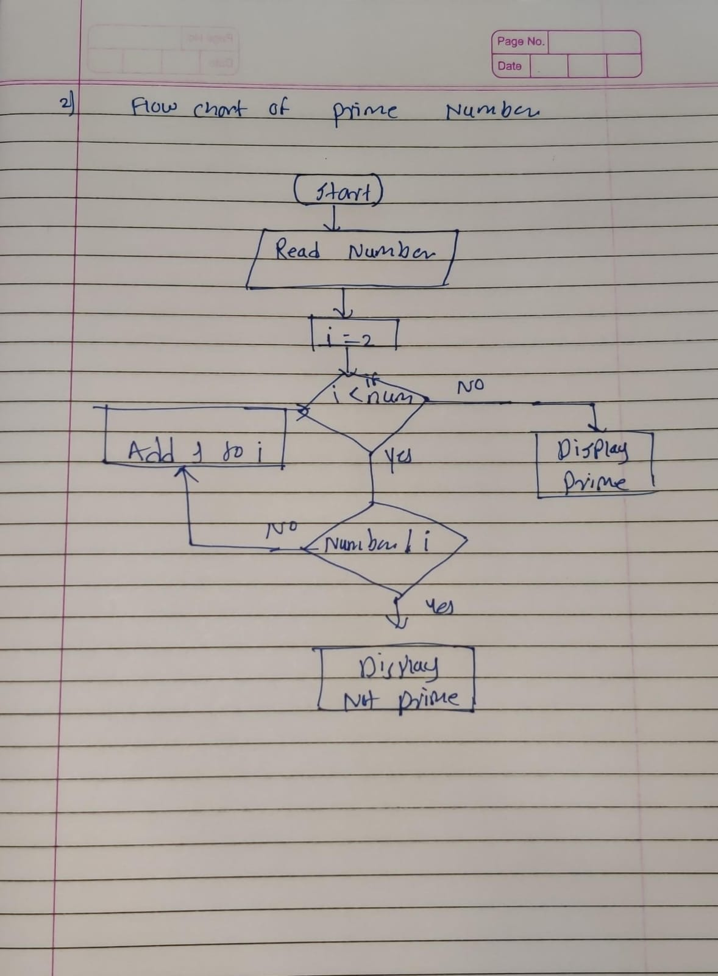

**Explanation:-**

This Java program checks if a given number is prime. It prompts the user to enter a number, and then uses a helper method isPrime to check if the number is prime. The isPrime method iterates from 2 to the square root of the number, checking if the number is divisible by any of these values. If it is, the method returns false. If the number is not divisible by any of these values, the method returns true, indicating that the number is prime. The program then prints out whether the number is prime or not.

**Output:-**

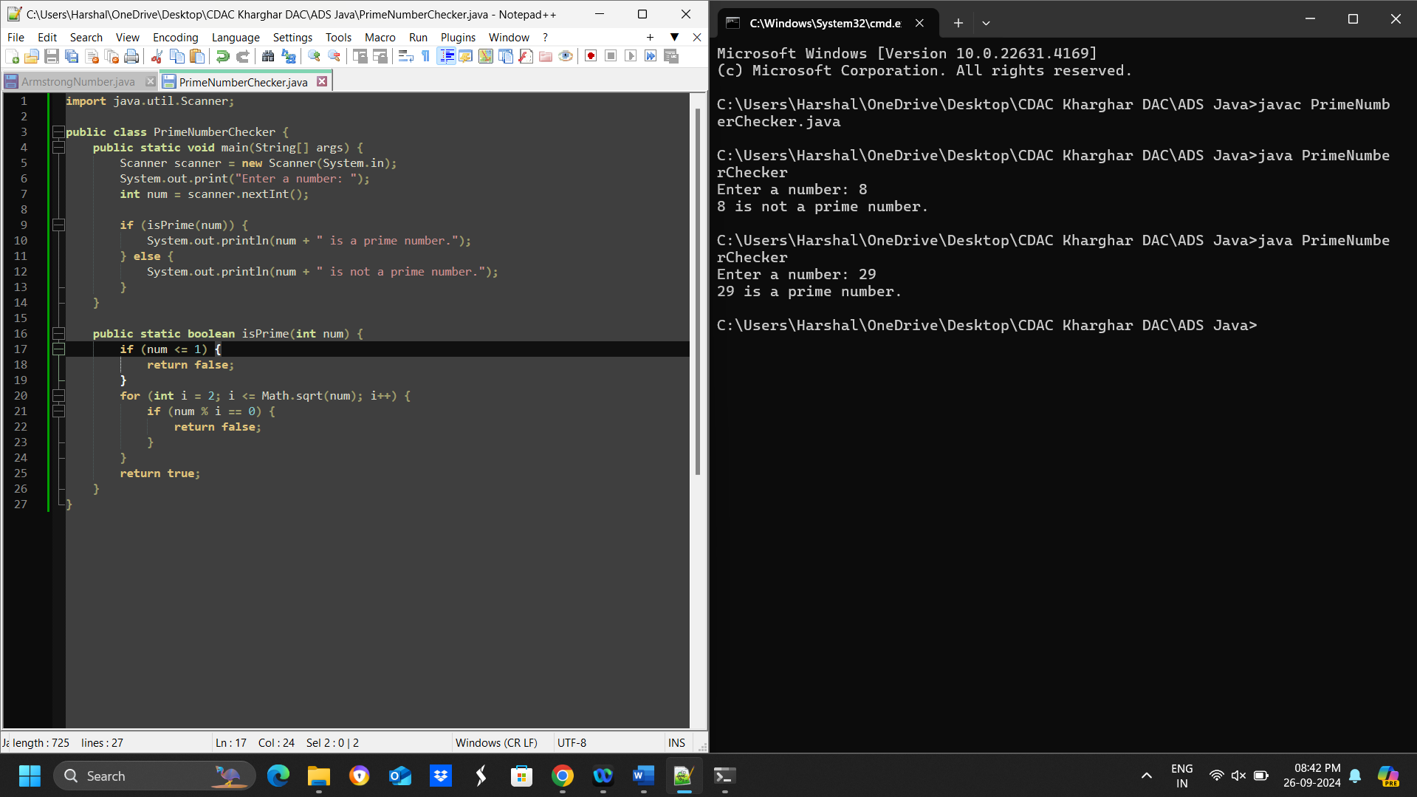

**Time and Space complexity:-**

The time complexity of the above program is O(√n) and the space complexity is O(1).

**3. Factorial**

**Problem: Write a Java program to compute the factorial of a given number.**

Program:-

import java.util.Scanner;

public class Factorial {

public static void main(String[] args) {

Scanner scanner = new Scanner(System.in);

System.out.println("Enter a number: ");

int num = scanner.nextInt();

long factorial = calculateFactorial(num);

System.out.println("Factorial of " + num + " is " + factorial);

}

public static long calculateFactorial(int num) {

long factorial = 1;

for (int i = 1; i <= num; i++) {

factorial *= i;

}

return factorial;

}

}

**Flow Chart:-**

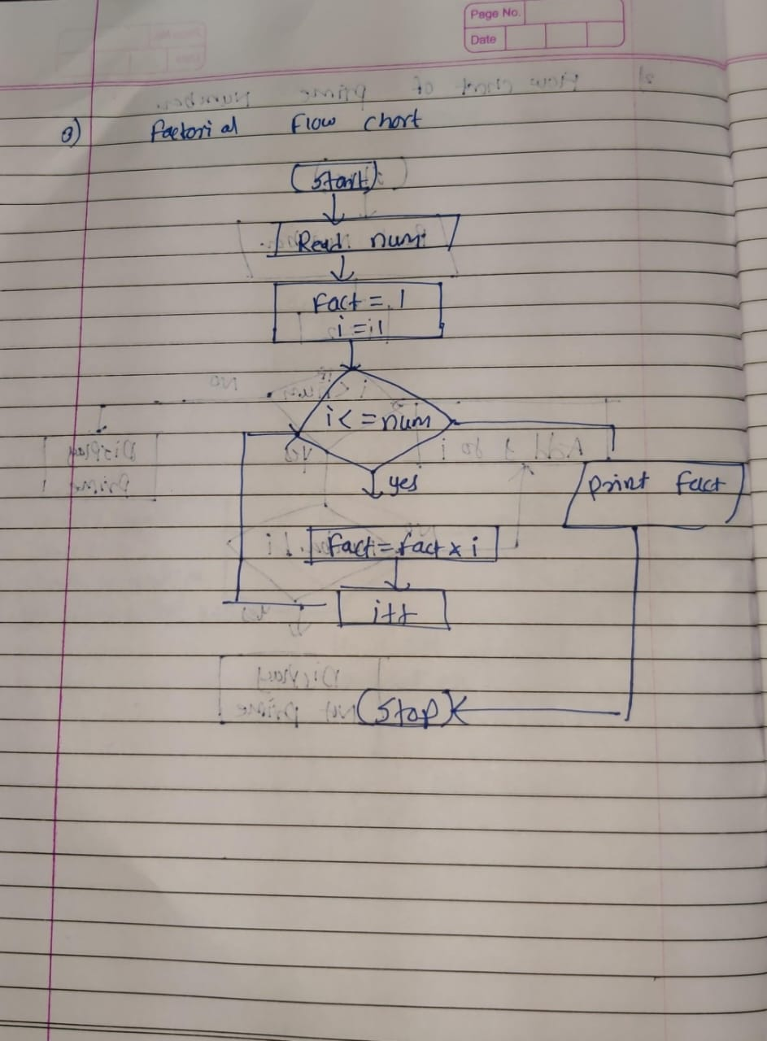

**Explanation:-**

* We use a Scanner object to read the input from the user.
* We prompt the user to enter a number and store it in the num variable.
* We call the calculateFactorial method, passing num as an argument.
* The calculateFactorial method uses a for loop to calculate the factorial of num. It starts with a value of 1 and multiplies it by each integer from 1 to num, inclusive.
* The final result is returned and printed to the console.

Note that we use a long data type to store the factorial result, since the factorial of a large number can exceed the range of an int.

**Output:-**

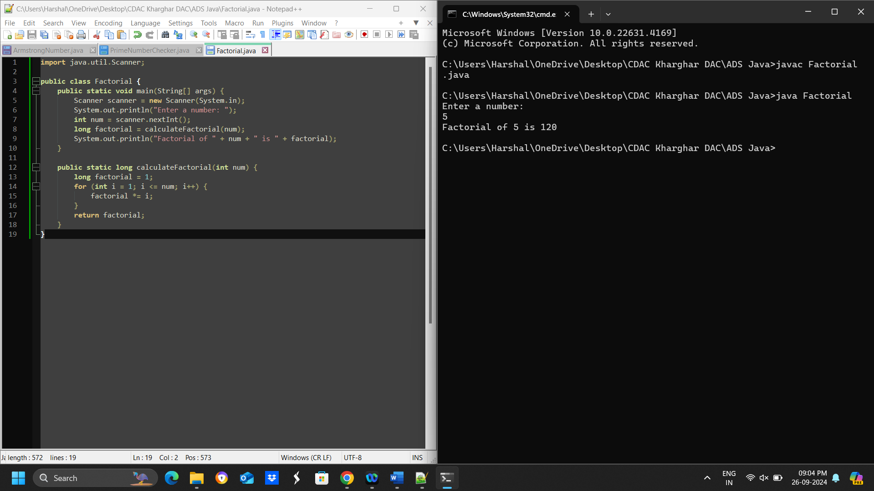

**Time and Space complexity:-**

The time complexity of the program is O(n)

The space complexity of the program is O(1)

**4. Fibonacci Series**

**Problem: Write a Java program to print the first n numbers in the Fibonacci series.**

**Program:-**

public class Fibonacci {

public static void main(String[] args) {

int n = 10; // change this to print the first 'n' numbers

int[] fib = new int[n];

fib[0] = 0;

fib[1] = 1;

for (int i = 2; i < n; i++) {

fib[i] = fib[i-1] + fib[i-2];

}

for (int i = 0; i < n; i++) {

System.out.print(fib[i] + " ");

}

}

}

**Flow chart:-**

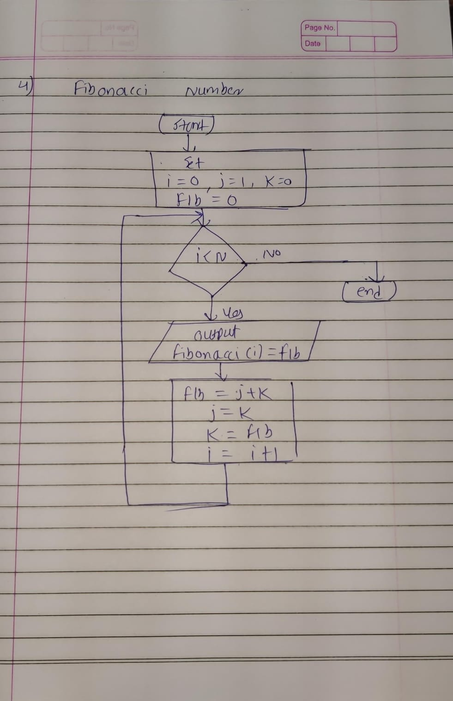

**Explanation:-**

* We create an array fib of size n to store the first n Fibonacci numbers.
* We initialize the first two elements of the array to 0 and 1, which are the first two numbers in the Fibonacci series.
* We use a for loop to calculate the remaining Fibonacci numbers using the recurrence relation fib[i] = fib[i-1] + fib[i-2].
* Finally, we use another for loop to print out the first n Fibonacci numbers.

You can change the value of n to print a different number of Fibonacci numbers**.**

**Output:-**

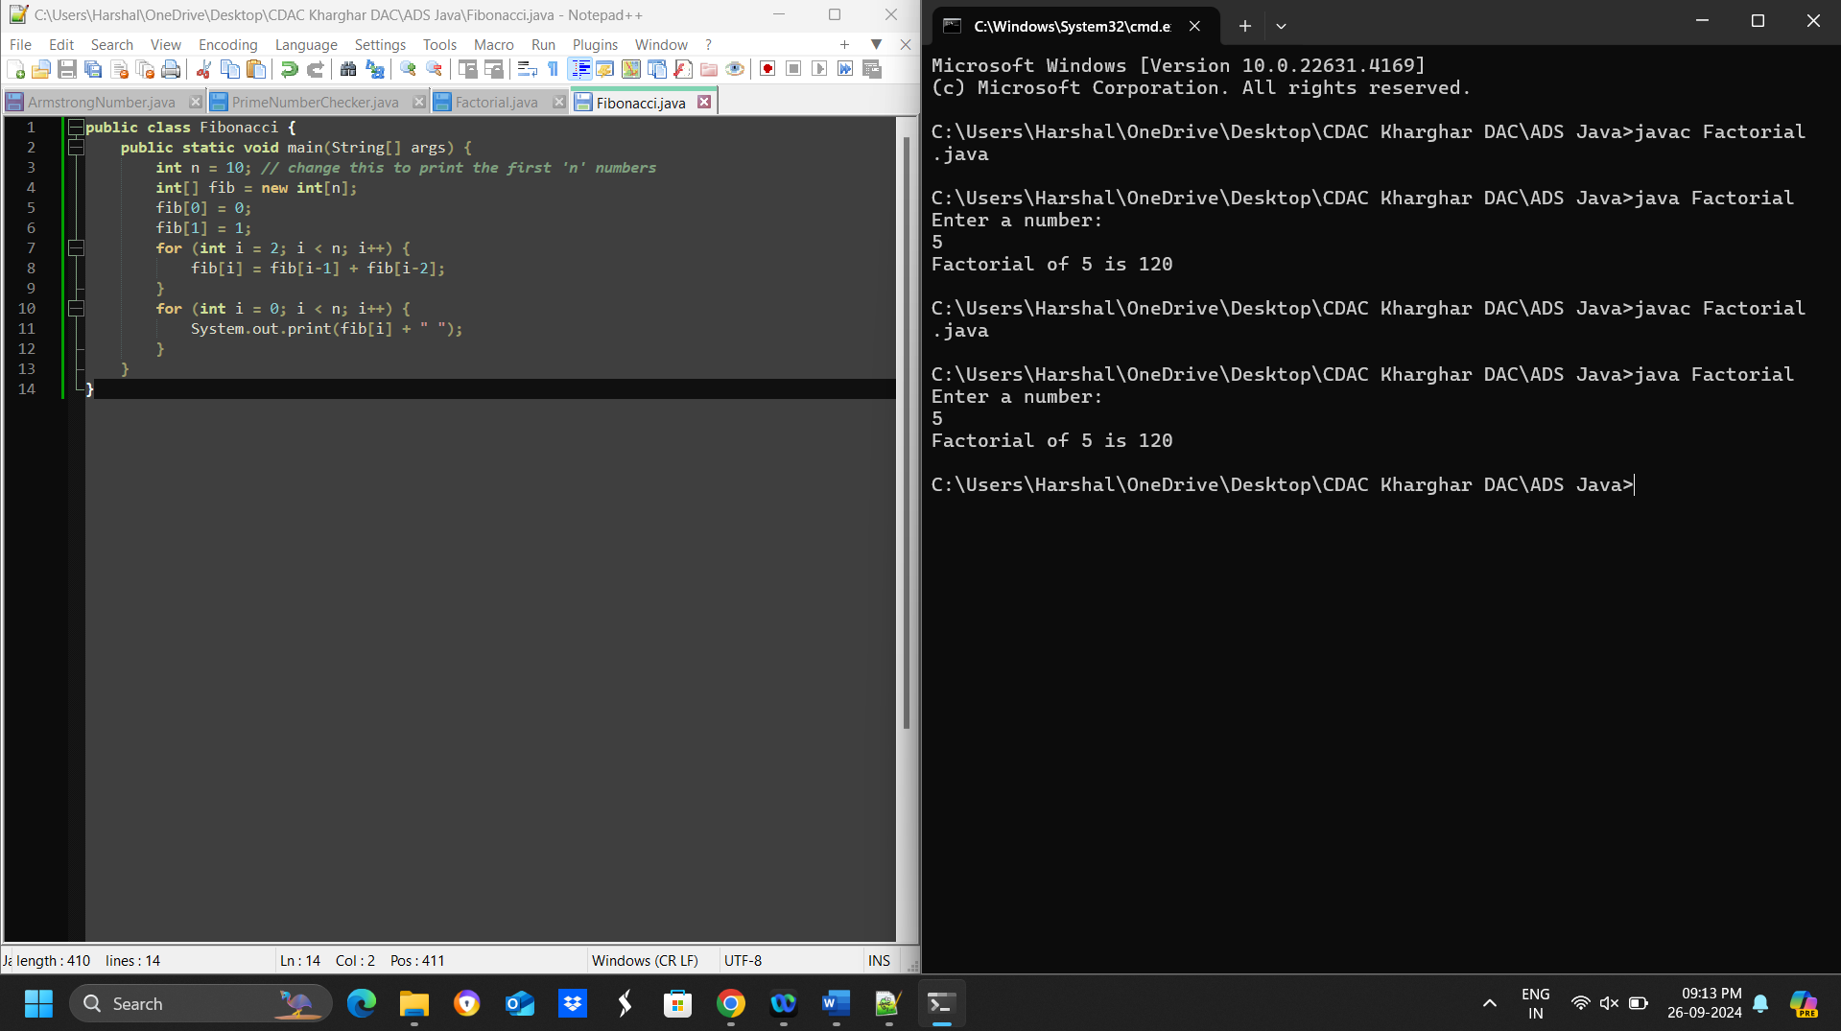

**Time and Space complexity:-**

The time complexity of the above program is O(n)

The space complexity of the above program is O(n).

**5. Find GCD**

**Problem: Write a Java program to find the Greatest Common Divisor (GCD) of two numbers.**

**Program:-**

import java.util.Scanner;

public class GCD {

public static void main(String[] args) {

Scanner scanner = new Scanner(System.in);

System.out.println("Enter the first number:");

int num1 = scanner.nextInt();

System.out.println("Enter the second number:");

int num2 = scanner.nextInt();

int gcd = findGCD(num1, num2);

System.out.println("The GCD of " + num1 + " and " + num2 + " is " + gcd);

}

public static int findGCD(int num1, int num2) {

if (num2 == 0) {

return num1;

} else {

return findGCD(num2, num1 % num2);

}

}

}

**Flow chart:-**

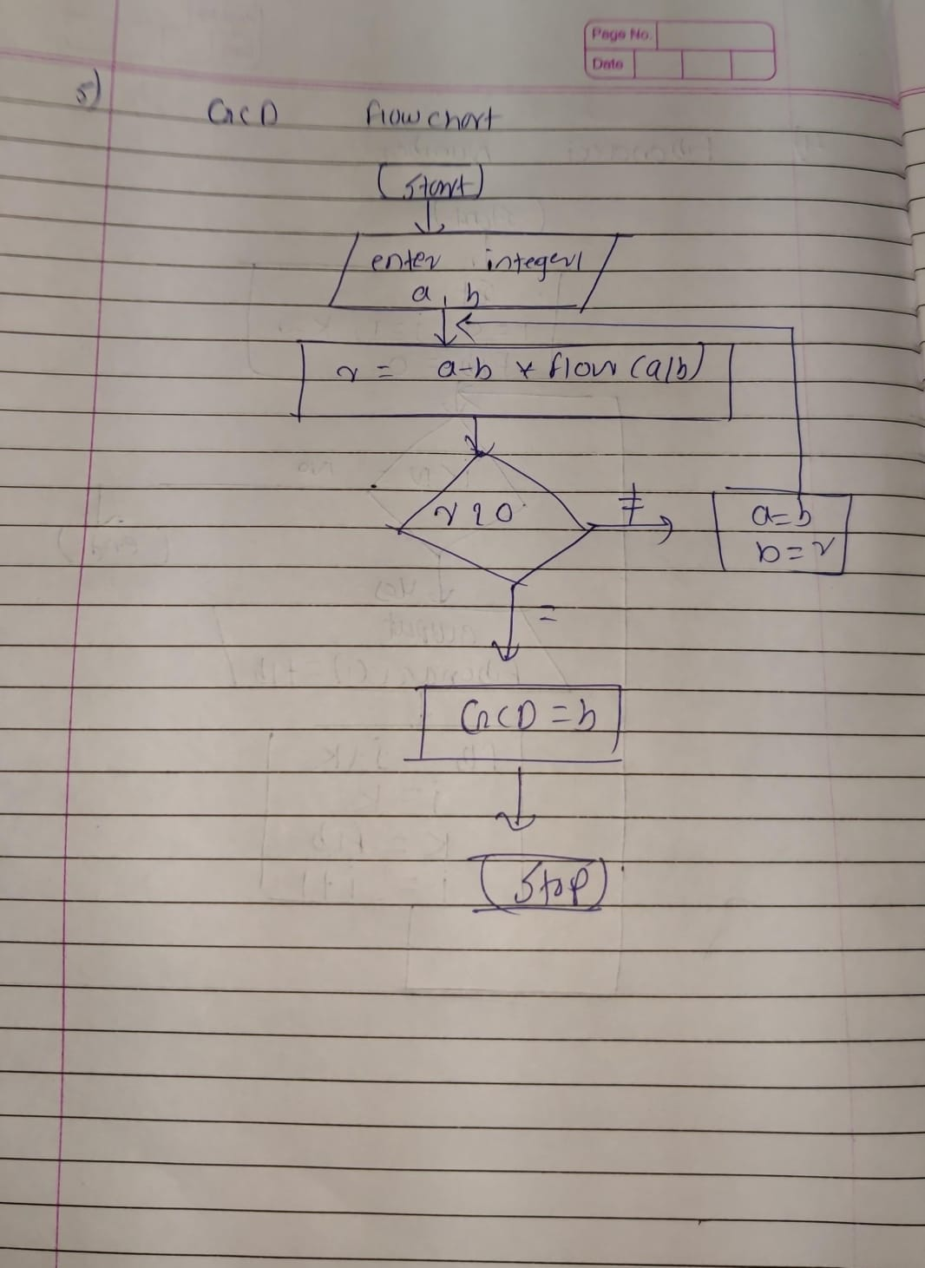

**Explanation:-**

* I added an import statement to bring in the Scanner class, which allows us to read user input.
* I created a Scanner object called scanner to read input from the user.
* I added two System.out.println statements to prompt the user to enter the two numbers.
* I used the scanner.nextInt() method to read the user's input and store it in the num1 and num2 variables.
* The rest of the program remains the same, using the findGCD method to calculate the GCD and printing the result to the console.

**Output:-**

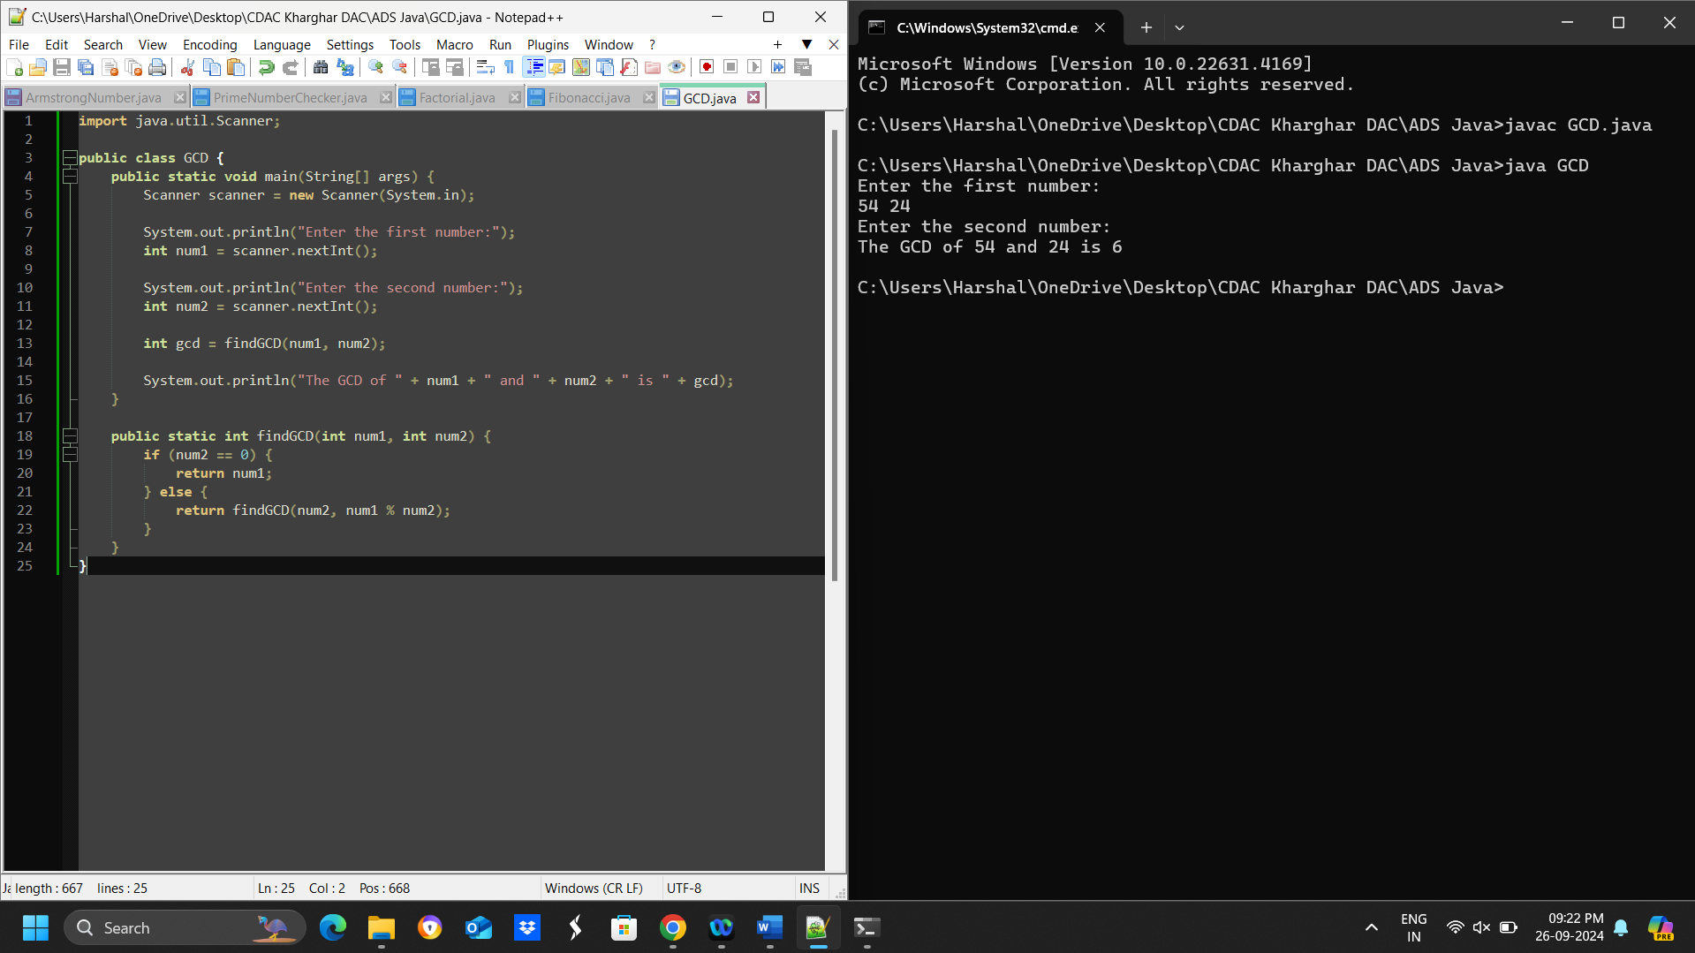

**Time and Space complexity:-**

The time complexity of the program is O(log(min(a, b))), where a and b are the input numbers.

The space complexity of the program is O(1)

**6. Find Square Root**

**Problem: Write a Java program to find the square root of a given number (using integer approximation).**

**Pragram:-**

import java.util.Scanner;

public class SquareRoot {

public static void main(String[] args) {

Scanner scanner = new Scanner(System.in);

System.out.print("Enter a number: ");

double num = scanner.nextDouble();

double sqrt = Math.sqrt(num);

System.out.println("The square root of " + num + " is " + sqrt);

}

}

**Flow chart:-**

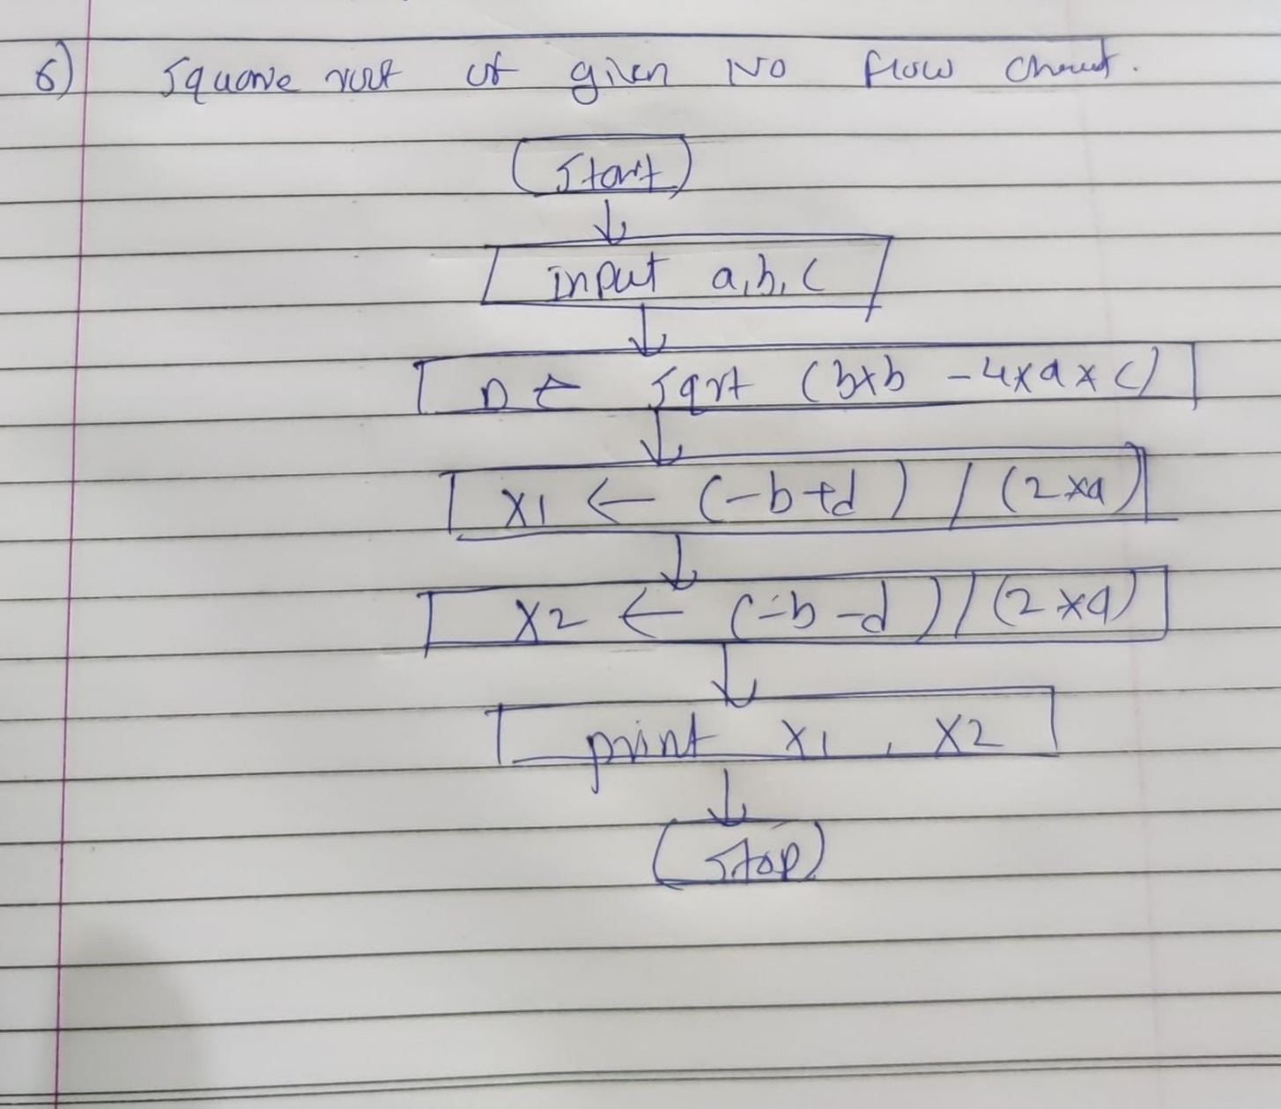

**Explanation:-**

* The user is prompted to enter a number.
* The input number is read using a Scanner object.
* The Math.sqrt() method is used to calculate the square root of the input number.
* The result is printed to the console.

**Output:-**

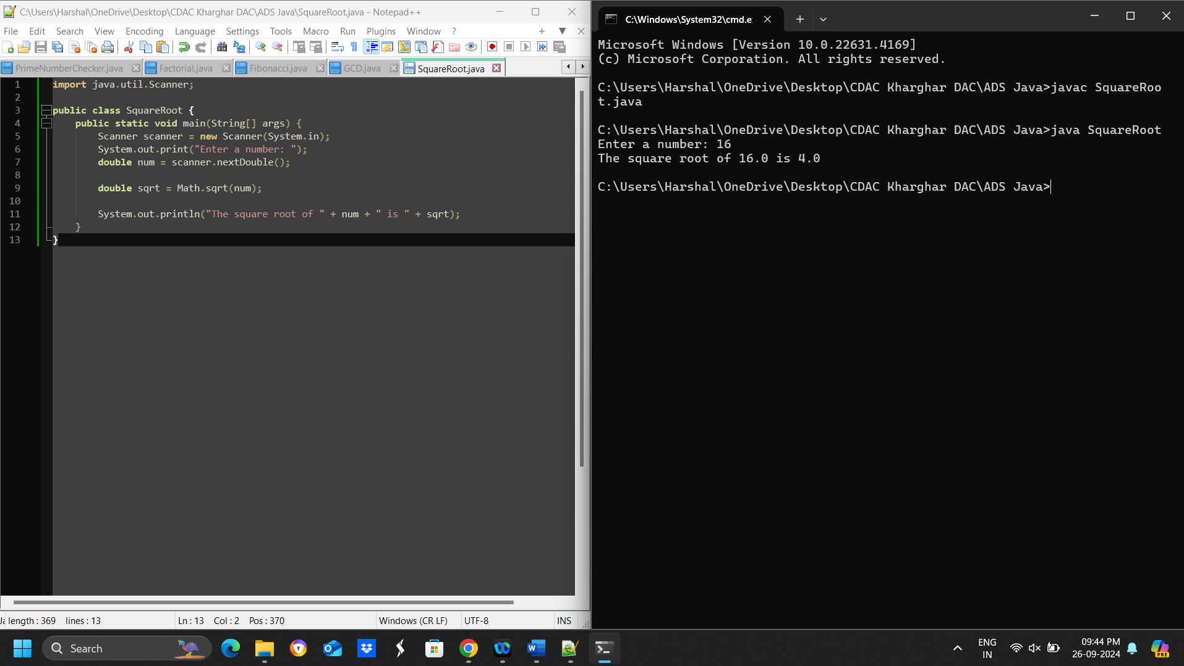

**Time and Space complexity:-**

the time complexity is O(1).

the space complexity is O(1).

**7. Find Repeated Characters in a String**

**Problem: Write a Java program to find all repeated characters in a string.**

**Program:-**

import java.util.Scanner;

public class RepeatedCharacters {

public static void main(String[] args) {

Scanner scanner = new Scanner(System.in);

System.out.print("Enter a string: ");

String str = scanner.nextLine();

for (char c : str.toCharArray()) {

int count = 0;

for (char d : str.toCharArray()) {

if (c == d) {

count++;

}

}

if (count > 1) {

System.out.println(c + ": " + count);

}

}

}

}

**Flow Chart:-**

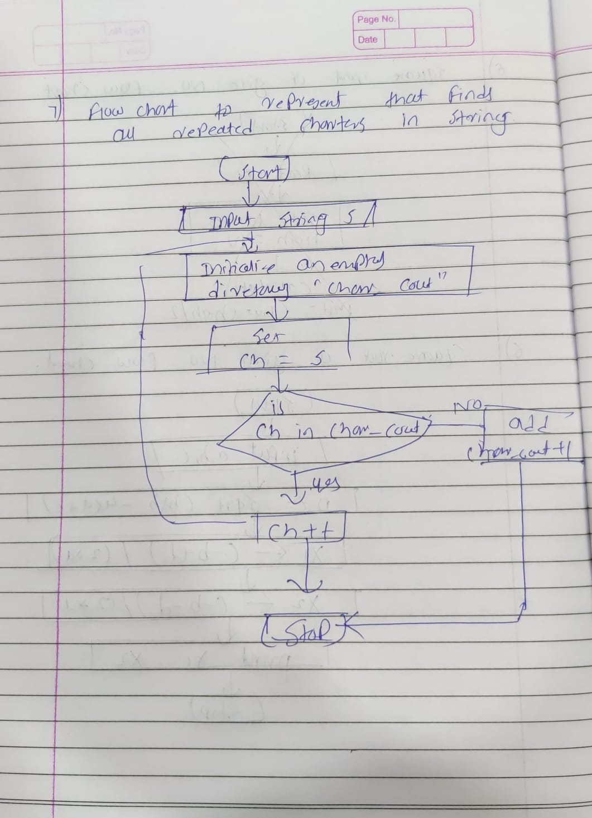

**Output:-**

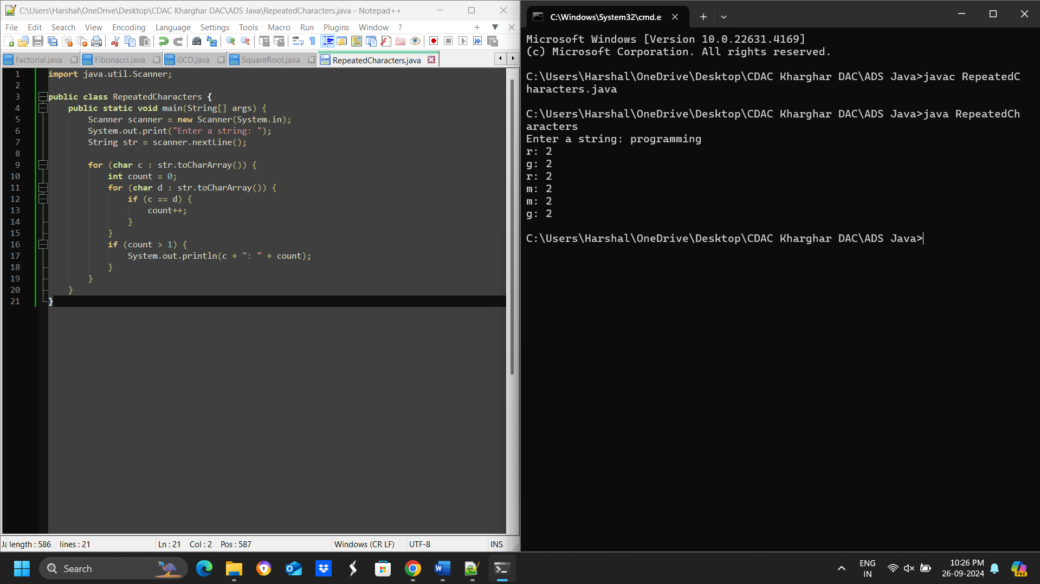

**Time and Space complexity:-**

The time complexity of the above program is O(n^2)

The space complexity of the above program is O(1)

**8. First Non-Repeated Character**

**Problem: Write a Java program to find the first non-repeated character in a string.**

**Program:-**

**import java.util.Scanner;**

**public class FirstNonRepeatedCharacter {**

**public static void main(String[] args) {**

**Scanner scanner = new Scanner(System.in);**

**System.out.print("Enter a string: ");**

**String str = scanner.nextLine();**

**for (int i = 0; i < str.length(); i++) {**

**boolean isRepeated = false;**

**for (int j = 0; j < str.length(); j++) {**

**if (i != j && str.charAt(i) == str.charAt(j)) {**

**isRepeated = true;**

**break;**

**}**

**}**

**if (!isRepeated) {**

**System.out.println("First non-repeated character: " + str.charAt(i));**

**return;**

**}**

**}**

**System.out.println("No non-repeated character found.");**

**}**

**}**

**Flow chart:-**



**Explanation:-**

* We import the Scanner class to read input from the user.
* We create a Scanner object scanner to read from the standard input (System.in).
* We prompt the user to enter a string using System.out.print.
* We read the input string using scanner.nextLine() and store it in the str variable.
* The rest of the program remains the same as before, iterating through the string to find the first non-repeated character.

**Output:-**

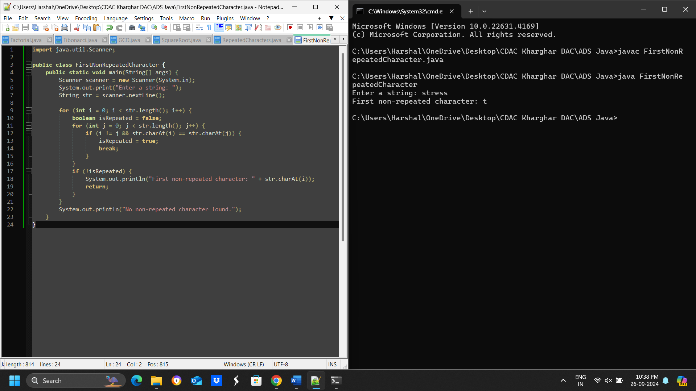

**Time and Space complexity:-**

This program has a time complexity of O(n) and a space complexity of O(1)

**9. Integer Palindrome**

**Problem: Write a Java program to check if a given integer is a palindrome.**

**Program:-**

import java.util.Scanner;

public class PalindromeChecker {

public static void main(String[] args) {

Scanner scanner = new Scanner(System.in);

System.out.print("Enter an integer: ");

int num = scanner.nextInt();

scanner.close();

if (isPalindrome(num)) {

System.out.println(num + " is a palindrome.");

} else {

System.out.println(num + " is not a palindrome.");

}

}

public static boolean isPalindrome(int num) {

int reversedNum = 0;

int originalNum = num;

while (num != 0) {

int digit = num % 10;

reversedNum = reversedNum * 10 + digit;

num /= 10;

}

return originalNum == reversedNum;

}

}

**Flow chart:-**

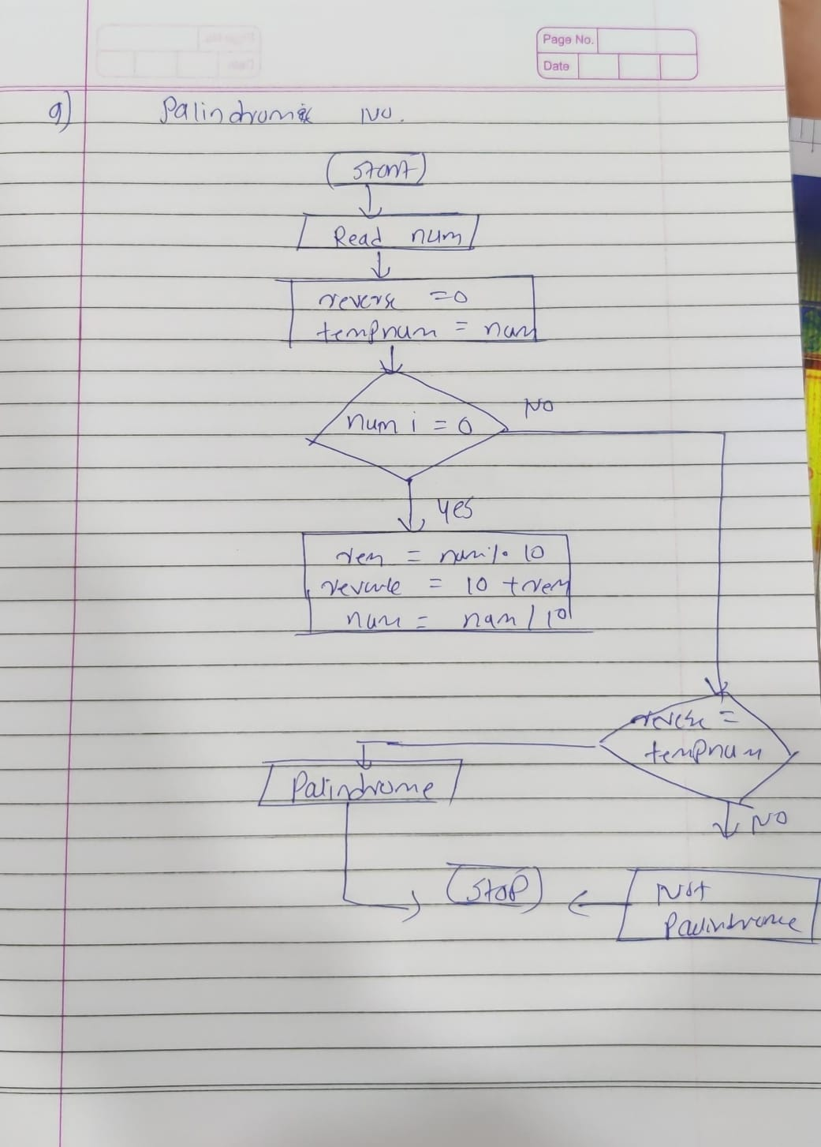

**Output:-**

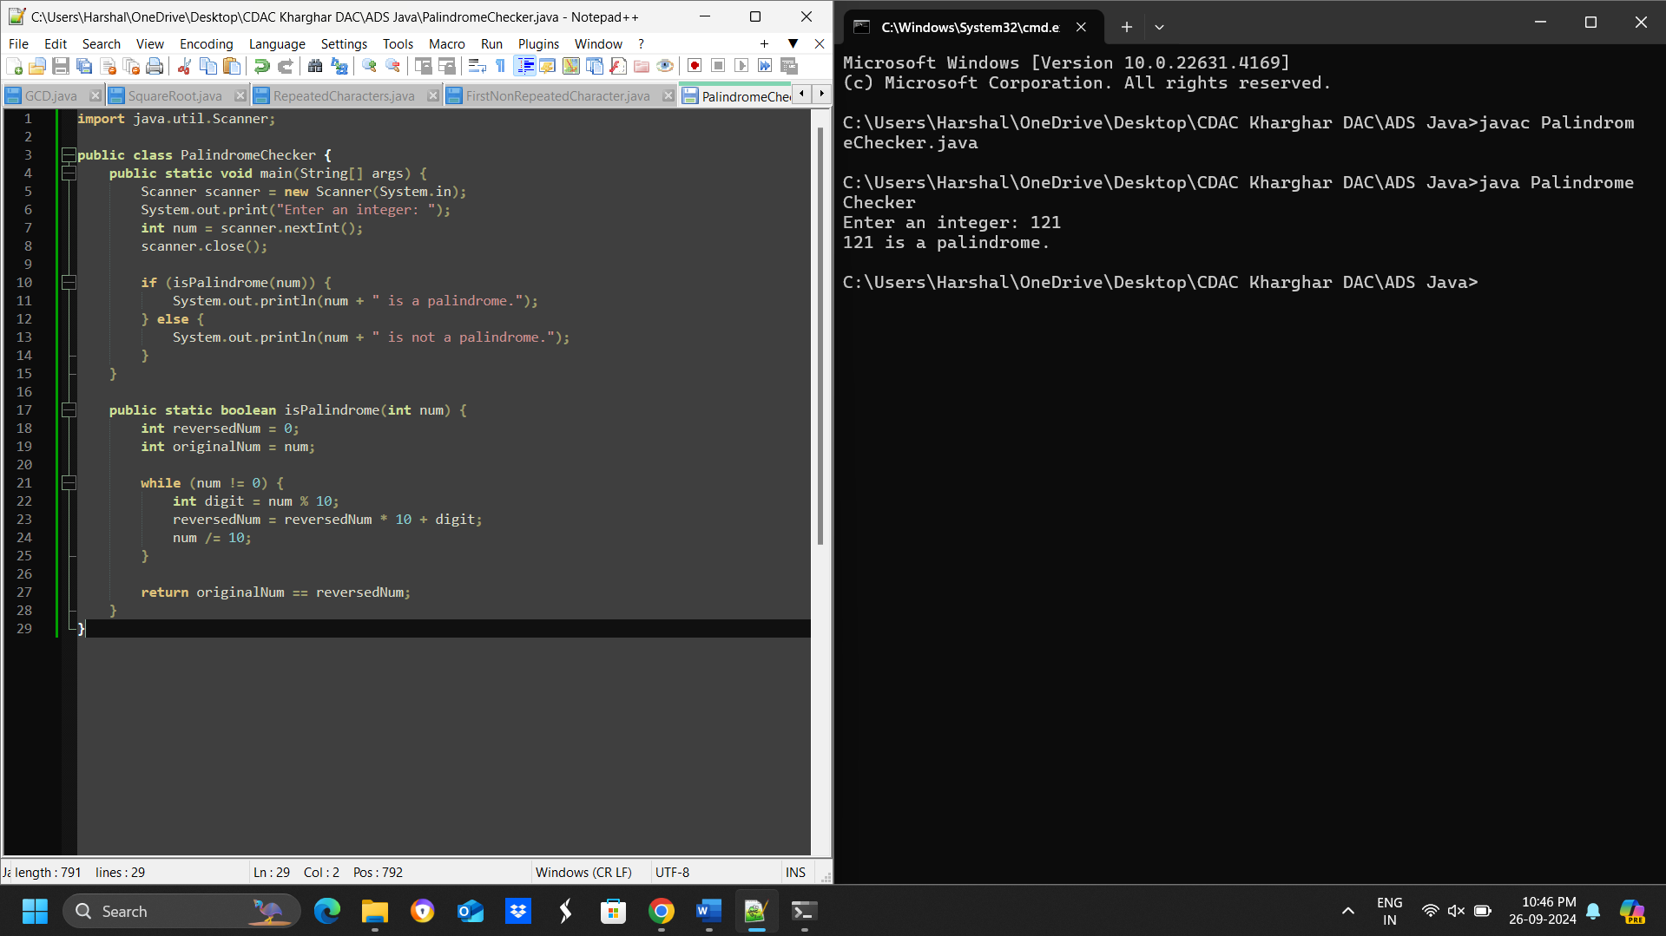

**Time and Space complexity:-**

 the time complexity is O(log10(n))

the space complexity is O(1)

**10. Leap Year**

**Problem: Write a Java program to check if a given year is a leap year.**

**Program:-**

**import java.util.Scanner;**

**public class LeapYear {**

**public static void main(String[] args) {**

**Scanner scanner = new Scanner(System.in);**

**System.out.print("Enter a year: ");**

**int year = scanner.nextInt();**

**scanner.close();**

**if (isLeapYear(year)) {**

**System.out.println(year + " is a leap year.");**

**} else {**

**System.out.println(year + " is not a leap year.");**

**}**

**}**

**public static boolean isLeapYear(int year) {**

**if (year % 4 == 0) {**

**if (year % 100 == 0) {**

**if (year % 400 == 0) {**

**return true;**

**} else {**

**return false;**

**}**

**} else {**

**return true;**

**}**

**} else {**

**return false;**

**}**

**}**

**}**

**Flow chart:-**

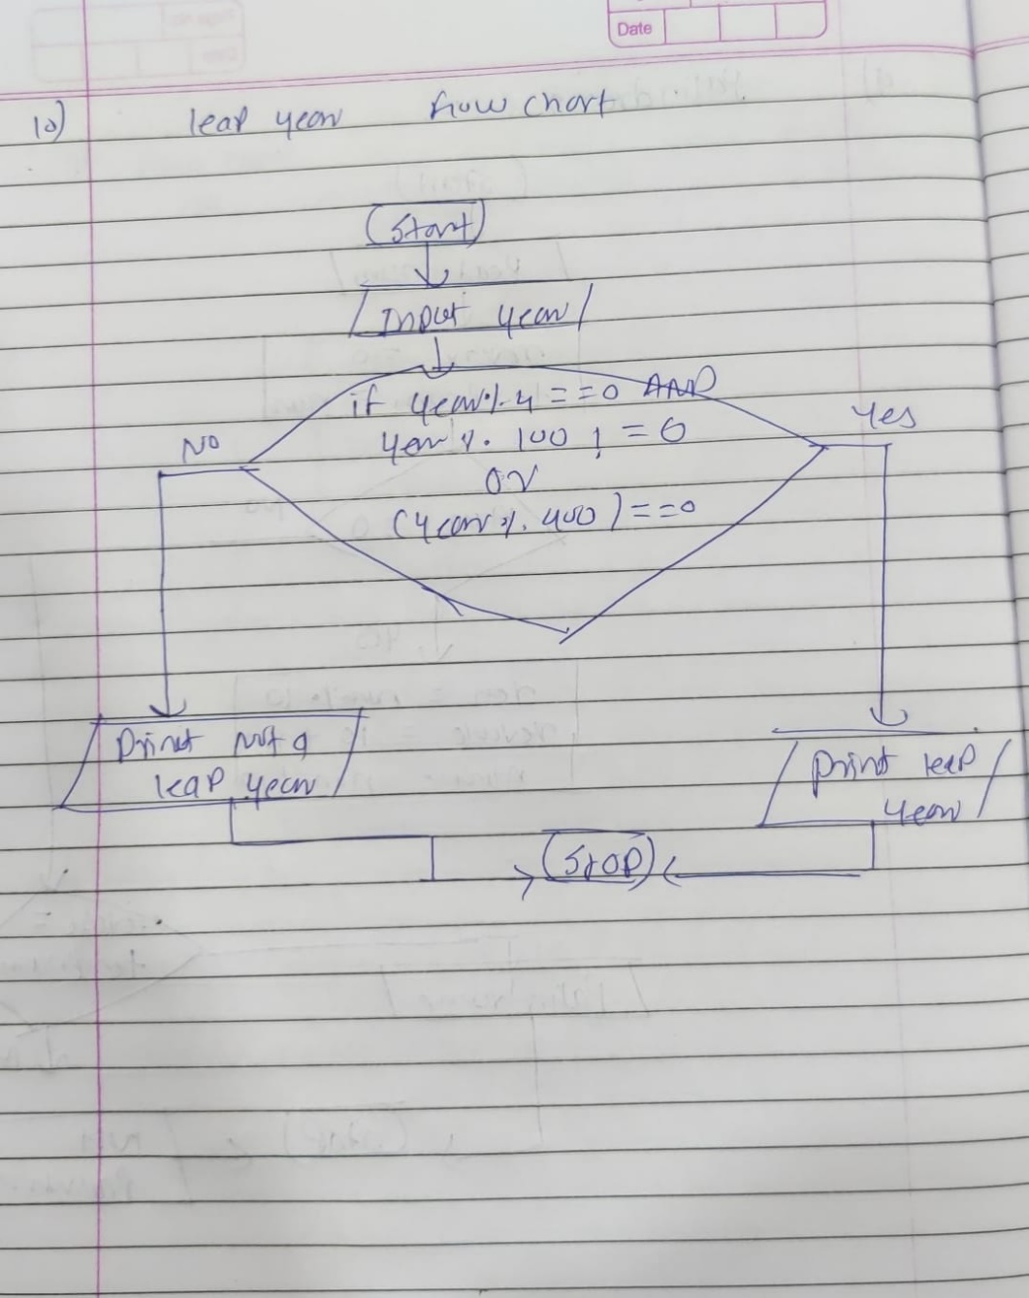

**Output:-**

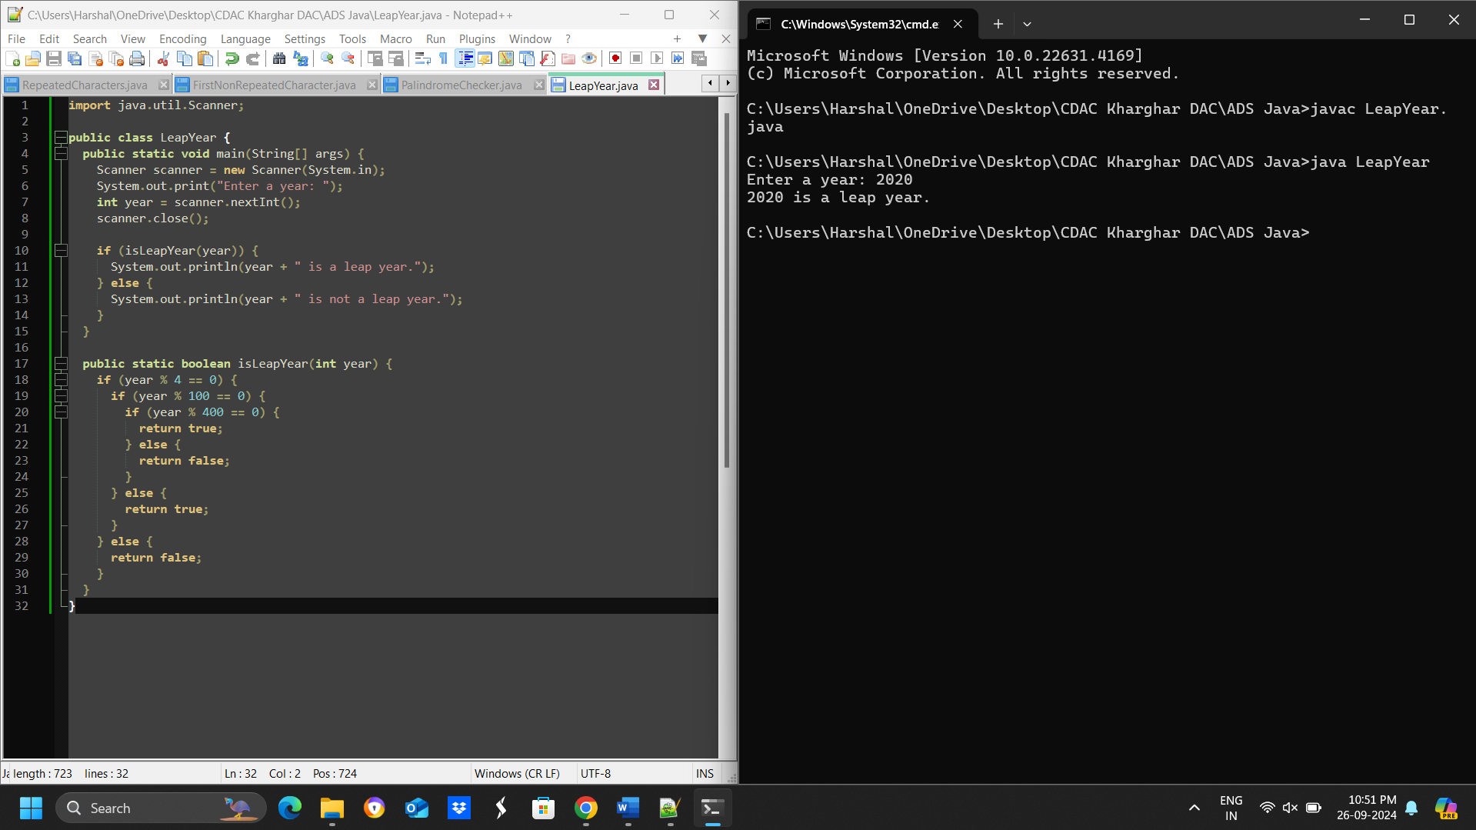

**Time and Space complexity:-**

the code has a time complexity of O(1) and a space complexity of O(1)